**security building blocks**

# Monitoring Identity & Access management

**Application security**

* *Azure monitor*
* *Security Center*
* *Azure resource manager*
* *Azure Active Directory*
* *RBAC*
* *Azure B2B*
* *Conditional access*
* *Identity protection*
* *Privileged identity management*
* *AD Connect*
* *Application management*
* *Azure B2C*
  + *SSL / TLS certificates.*
  + *Azure Active directory and other identity services integration*
  + *Secure deployment of code*

# Data security

* *Azure SQL database advanced data security*
* *Azure SQL database always encrypted*
* *Encryption in transit and rest*
* *Security for Cosmos DB, Data*

***Azure Security***

# Governance

* *Azure policies*
* *Security policies*
* *Guest security configuration*
* *Locks*

# Network security

* + *DDoS protection*
  + *Azure Firewall & resource firewalls*
  + *NSG & ASG*
  + *Service end points and policies*
  + *Remote access management*

lake store, Hdinsight etc.

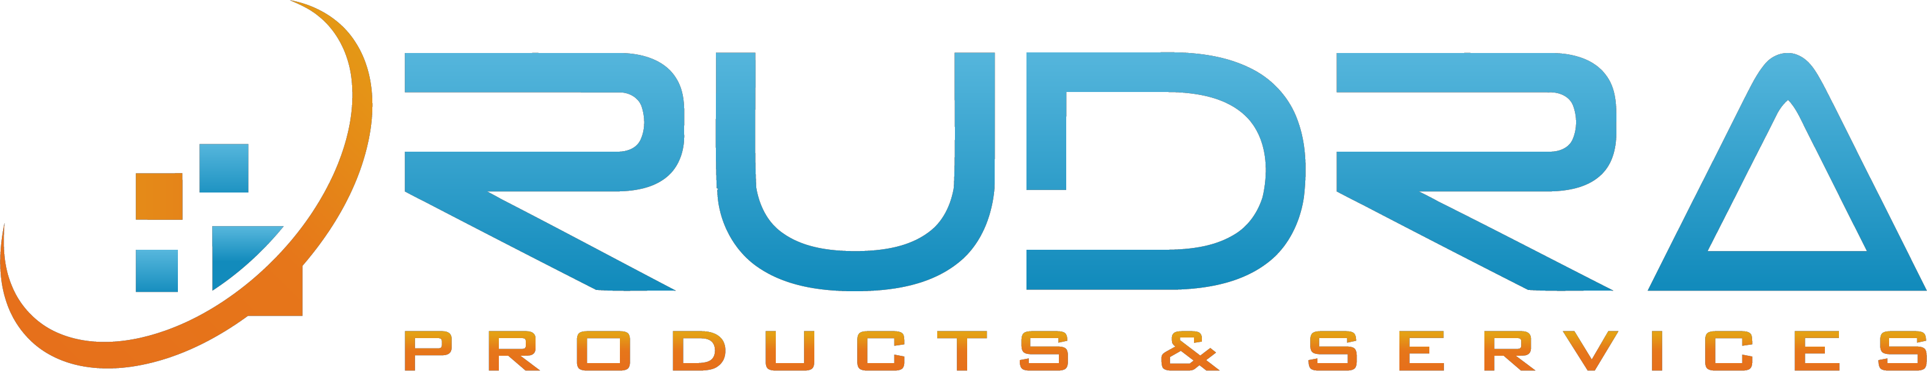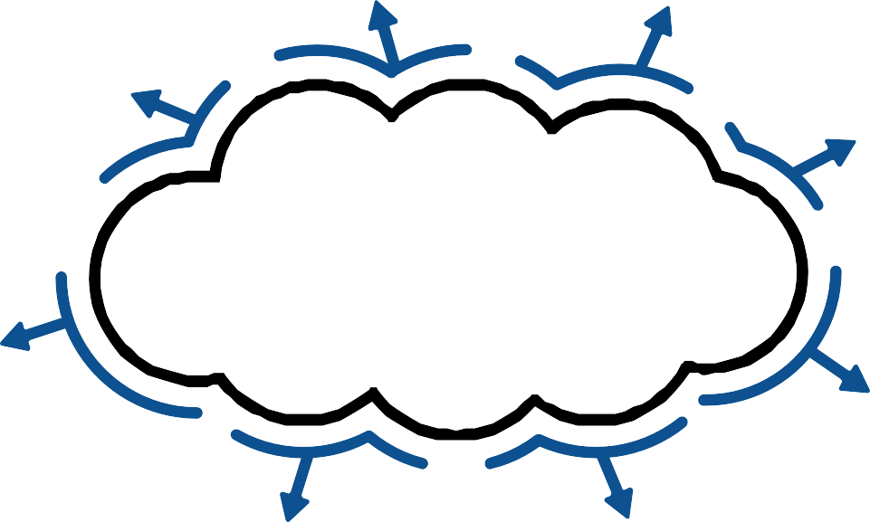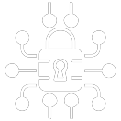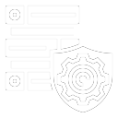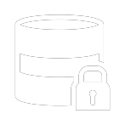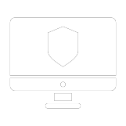

* *Key Vault*

# Host security

* *VM End point protection*
* *Update management solution*
* *Azure Disk encryption*

# Storage security

* *Storage firewall*
* *Access keys & SAS keys*
* *Azure active directory integration*
* *Storage service encryption*
* 